**Project Design Phase-II**

**Data Flow Diagram & User Stories**

|  |  |
| --- | --- |
| Date | 14 October 2022 |
| Team ID | PNT2022TMID00086 |
| Project Name | Project – Plant disease prediction and fertilizer recommendation system |
| Maximum Marks | 4 Marks |

**Data Flow Diagrams:**

A Data Flow Diagram (DFD) is a traditional visual representation of the information flows within a system. A neat and clear DFD can depict the right amount of the system requirement graphically. It shows how data enters and leaves the system, what changes the information, and where data is stored.

Example: DFD Level 0 (Industry Standard)

**Example:** [**(Simplified)**](https://developer.ibm.com/patterns/visualize-unstructured-text/)

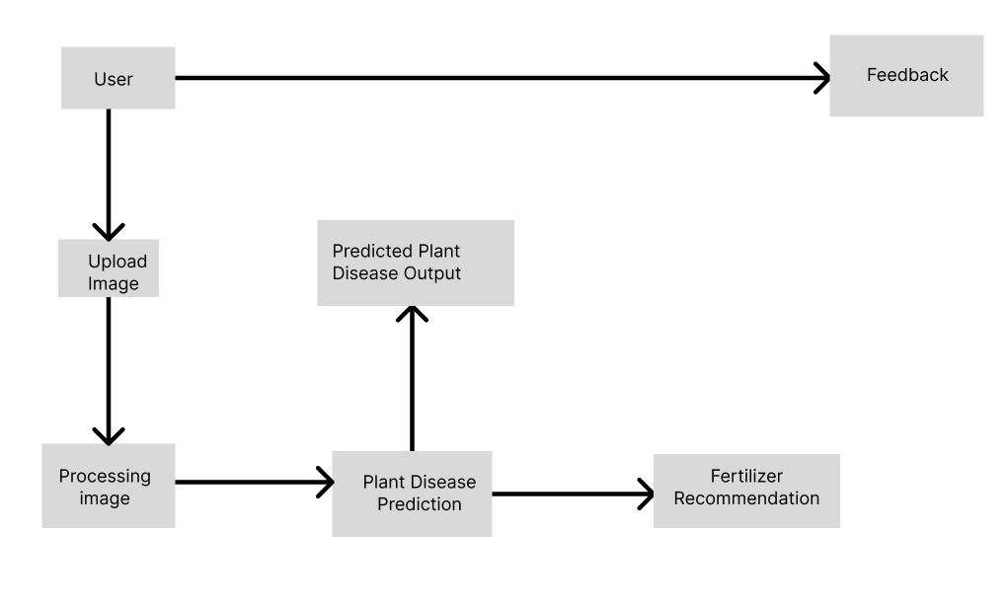

**](https://developer.ibm.com/patterns/visualize-unstructured-text/)**

**User Stories**

Use the below template to list all the user stories for the product.

| **User Type** | **Functional Requirement (Epic)** | **User Story Number** | **User Story / Task** |
| --- | --- | --- | --- |
| Agriculturalist (Mobile/web user) | Registration | USN-1 | As a user, I can register for the application by entering my email, password, and confirming my password. |
|  |  | USN-2 | As a user, I will receive confirmation email once I have registered for the application |
|  |  | USN-3 | As a user, I can register for the application through yahoo |
|  |  | USN-4 | As a user, I can register for the application through Gmail |
|  | Login | USN-5 | As a user, I can log into the application by entering email & password |
|  | Uploading image | USN-6 | Upload the image of the affected plant |
|  | Image processing | USN-7 | Prediction of plant disease |
|  | Fertilizer recommendation | USN-8 | Appropriate fertilizer is recommended |
|  | User feedback | USN-9 | User provides feedback after usage of fertilizer |